Final Exam – Fall 2015
CS583: Data Mining and Text Mining

Name:_____________________________ UIN__________________________

Instructions:
- This is a close book examination
- The paper has 9 questions and the full mark is 100.

 | Full Mark | Your Mark
Q1 | 30
Q2 | 5
Q3 | 5
Q4 | 5
Q5 | 10
Q6 | 10
Q7 | 10
Q8 | 10
Q9 | 15
Total | 100

1. (30%) Answer the following questions very briefly (2% each).
- Write the confidence and the support of the association rule, X → Y, using probabilities, where X and Y are itemsets? Note that you will need to use the count(A) function, which gives the number of times that itemset A appears in the transaction data.

- Which classification algorithms perform feature selection automatically, KNN, decision tree, naïve Bayesian, SVM?

- In mining association rules with multiple minimum supports, what are the two strategies used to reduce the number of rules generated?

- The approach that compares items based on their pattern of ratings across users is called item-based CF. True or false?

- We say that a positive or negative opinion must have a target. True or false?

- Based on the graph below, which two nodes have the biggest co-citation value?
1
2
3
7
8
4
6
5
- Based on the graph above, which two nodes have the biggest bibliographic coupling value?

- The HITS algorithm produces two scores for each node. What are they?

- What are the parameters of the multinomial distribution?

- Give the equation for the conditional independence assumption used in naïve Bayesian classification.

- What is the maximum value of AUC? What is the AUC value if the prediction is completely random?

Multiple-choice questions. There is only one correct answer for each question.
(12). In PU learning, what does the theory say about how the problem may be solved?
- It can be solved as an optimization problem with labeled and unlabeled examples
- It can be solved as a machine learning problem
- It can be solved as a constrained optimization problem that tries to minimize the number of unlabeled examples labeled as positive with some constraints
- It can be solved as a constrained optimization problem that tries to minimize the number of labeled examples labeled as negative with some constraints

(13). What are the differences between PU learning and LU learning?
- PU learning does not use negative examples in learning
- LU learning uses positive and unlabeled examples in learning
- LU learning uses a lot of positive examples and a small number of negative examples.
- PU learning uses a small number of positive examples with a few negative examples.

(14). What is the main assumption of co-training?
- The feature set can be partitioned into two subsets and each subset is sufficient to build a good classifier.
- The feature set can be partitioned into two subsets and one subset is not needed.
- The feature set can be used to build two classifiers and each classifier can perform classification well.
- The feature set can be used to build two classifiers and two classifiers can work together to build a better classifier.

(15). The EM algorithm for learning from labeled and unlabeled examples uses the following strategy.
- Runs the Naïve Bayesian classifier iteratively until it gets the best F score.
- Runs the Naïve Bayesian classifier iteratively until it gets the best accuracy.
- Runs the Naïve Bayesian classifier iteratively until it converges.
- Runs the Naïve Bayesian classifier iteratively until it converges to the global optimum.

2. (5%) Given the following examples, we want to learn to extract the area codes using the Stalker algorithm. Give the learned rules.

1: <li> 205 Willow, <i>Glen</i>, Phone <i>773</i>-366-1987</li>
2: <li> 25 Oak, <i>Forest</i>, Phone (800) 234-7903 </li>
3: <li> 324 Halsted St., <i>Chicago</i>, Phone <i>800</i>-996-5023 </li>
4: <li> 700 Lake St., <i>Oak Park</i>, Phone: (708) 798-0008 </li> </p>

- (5%) We use matrix factorization for recommendation of movies to users. Assume that we have already factored a training user-movie rating matrix to the following user-aspect matrix U and movie-aspect matrix M, what is the predicted rating of user 2 on movie 4? U_{ij} is the score from user i to aspect j, and similarly M_{ij} is the score from movie i to aspect j.
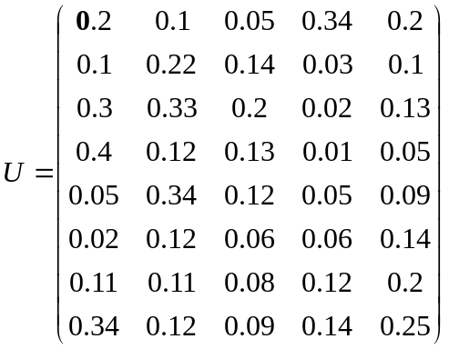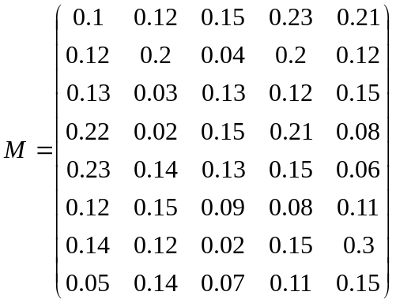
4. (5 marks) produce all opinion quintuples from the following review.
- User-name: Abc123 – Time: 05/01/2008 -- “I love my iPhone. The touch screen is cool. The voice quality is clear too, although the battery life is not long. However, my mom is mad with me as I didn’t tell her before I bought the phone.”

5. (10%) Use complete-link agglomerative clustering to cluster the following one dimensional data points: 1, 3, 5, 6, 11, 20, 24, 28, 30, 35. You are required to draw the cluster tree and write the value of the cluster center (mean) represented by each node next to the node. Use Euclidean distance as the distance measure.

6. (10%) Use the k-means clustering algorithm to cluster the following one dimension data points into 3 clusters,
1, 3, 7, 8, 11, 13, 16, 18, 20, 22
Give the result (centroid and data points in each cluster) of each iteration. Use 3, 11 and 16 as the initial seeds (centroids). What is the final sum of squared error (SSE)?

7. (10%) Build an inverted index using the following three sentences (is, are, in, many, has, and and can be removed as stopwords). You should include the position of each word in the index so that word proximity can be considered in search.

S1: “Web mining is useful in many internet companies”
S2: “Data mining has many techniques and algorithms”
S3: “Sentiment analysis applications are using in companies”

8. (10%) Each line below represents a sequence of clicks of a user on an e-commerce web site.
<{1}{6}>
<{1}{4}{2}{3}{5}>
<{1}{3}{4}{5}>
<{1}{4}{8}{9}{5}>
<{1}{3}{6}{7}>
<{1}{3}{4}{7}>
<{1}{3}{4}{8}>
<{1}{4}{3}{6}{9}>
<{3}{6}{4}{7}>
<{3}{6}{7}>
{x} represents a single click. The web site has two items, 5 and 7, for sale, which are in page {5} and page {7}. We want to mine sequential rules to direct users to these pages as soon as possible without too many clicks. Our sequential rules are of the following form:
S → {y},
where S is a sequence and y is either 5 or 7 because we want users to buy. The rule says that if one’s click sequence contains S, then one wants to go to page {y} with some confidence.
Questions:
(a) (5%) Find at least 3 rules with the minimum support of (>=) 20% and minimum confidence of (>=) 50%.
(b) (5%) In testing, if a new user has made the clicks <{2}{6}>, which item would you recommend him to buy (or direct him to)? Use your rules to explain why. What about <{1}{4}>?

9. (15%) Given the hyperlink graph below
3

4

6

1

2

5

We want to use the Markov chain model to compute the PageRank value of each node.
a. Give the initial transition probability matrix.
b. If the transition probability matrix is not a stochastic matrix, convert it to a stochastic matrix by using the second method (adding artificial links). Show the resulting matrix.
c. If the resulting matrix is not irreducible, convert it to an irreducible matrix. Show the matrix with d = 0.9.

